
CENTRAL WEST EDUCATION DIVISION
2026 MALAWI SCHOOL CERTIFICATE OF EDUCATION MOCK EXAMINATIONS

AGRICULTURE
PAPER I
Theory

Tuesday, 17th March (100 Marks) Subject Number: M012/I

Time Allowed: 2 hours
8:00 -10:00 am
Instruction
Question number | Tick if answered | Do not write in these columns
1
2
3
4
5
6
7
8
9
10
11
12
13
Total

- This paper contains 11 printed pages. Please check.
- This paper has sections A and B. Section A has ten questions and section B has three questions
- Answer all questions in the spaces provided. Marks are indicated against each part of the question
- Write your examination number on all pages.
- In this table provided on this page, tick against the question number you have answered.
- At the end of the examination, hand in your examination paper to the invigilator.

CWED @2026

Section A (70 marks)

- a). Explain any one way in which each of the following measures can help to conserve soil
- construction of terraces.
_____________________________________________________________________________________________________________________________________________________________________________________________________________________
(2marks)
- Mulching.
_____________________________________________________________________________________________________________________________________________________________________________________________________________________
(2marks)
b). State any two ways of solving the following problems faced by milk production cooperatives
- Lack of storage facilities.
______________________________________________________________________________________________________________________________________________
(2marks)
- Lack of leadership skills.
______________________________________________________________________________________________________________________________________________
(2marks)
- a). State any two importance of infrastructure services in improving agricultural production
___________________________________________________________________________________________________________________________________________________________________________________________________________________________________________________________________________________________________________________________________________________________________

(2marks)
b). Explain the importance of each of the following management practices done to calves:
- disbudding.
______________________________________________________________________________________________________________________________________________
(2marks)

- Branding.
_____________________________________________________________________________________________________________________________________________
(2marks)
c). Define conservation agriculture
______________________________________________________________________________________________________________________________________________
(2marks)
- Figure 1 is a vegetative planting material. Use it to answer the questions a and b

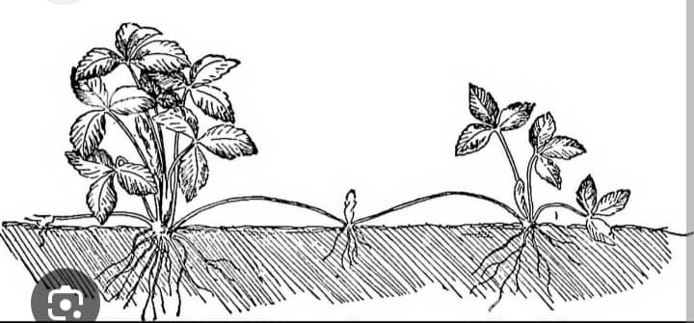
Figure 1
- Identify the planting material in figure 1.
_______________________________________________________________________
(1mark)
- State any two advantages of using the planting material in crop production.
_____________________________________________________________________________________________________________________________________________________________________________________________________________________
(2marks)
- State any two roles of processors as marketing agencies in ensuring food security.
_____________________________________________________________________________________________________________________________________________________________________________________________________________________
(2marks)
- Give any two examples of mango pests.
_____________________________________________________________________________________________________________________________________________
(2marks)
- a). State any one advantage of outbreeding in livestock improvement.
____________________________________________________________________________________________________________________________________________________
(1mark)
b). Describe the following farm business management principles
- opportunity cost.
_____________________________________________________________________________________________________________________________________________________________________________________________________________________
(2marks)
- Diminishing marginal returns.
_____________________________________________________________________________________________________________________________________________________________________________________________________________________
(2marks)
- Table 1 shows record kept by a farmer
Date | Item | Quantity | Remarks
23/6/2024 | plough | 1
22/7/2024 | Milking machine | 1
02/8/2024 | Ox-cart | 2

Table 1

- Identify the type of farm record shown in Table 1.
_________________________________________________________________________
(1mark)
- A plough bought in 2022 at K350,000 has a salvage value of K50,000. The estimated lifespan of the machinery is 5 years.

- Calculate the annual depreciation of the machinery. Show your working.

(2marks)
- Calculate the value of the machinery in 2024. Show your working.
(2marks)
- State any two characteristics of Malawi Zebu as a beef breed.
_____________________________________________________________________________________________________________________________________________________________________________________________________________________
(2marks)
- a). Explain any two ways in which marketing agricultural agencies are important.
________________________________________________________________________________________________________________________________________________________________________________________________________________________________________________________________________________________________________
(4marks)
b). Describe any two ways to ensure women use farm machinery same as men in production.
________________________________________________________________________________________________________________________________________________________________________________________________________________________________________________________________________________________________________
(4marks)
c). State any two effects of soil temperature on the growth of maize.
______________________________________________________________________________________________________________________________________________________________________________________________________________________________
(2marks)
- a). State any two ways of modifying low soil PH.
_________________________________________________________________________________________________________________________________________________________________________________________________________________________________
(2marks)
b). Describe any one limitation of biogas as source of power in smaller holder farms.
______________________________________________________________________________________________________________________________________________________
(2marks)
c). State any two activities that are done when managing mushroom fruiting.
_________________________________________________________________________________________________________________________________________________________________________________________________________________________________
(2marks)
d). State any two ways of improving trading at village level.
_________________________________________________________________________________________________________________________________________________________________________________________________________________________(2marks)

- Figure 2. Shows a pasture utilization method. Use it to answer questions a, b and c.
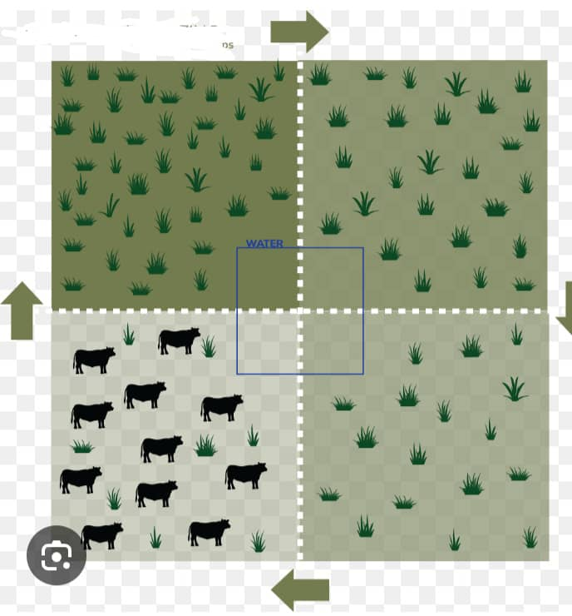
a). Identify the pasture utilization method shown
___________________________________________________________________________
(2marks)
b). Describe any one way in which the system ensures control of ticks in animals.
____________________________________________________________________________________________________________________________________________________
(2marks)
c). State one limitation of the system to smaller holder farmers.
____________________________________________________________________________________________________________________________________________________
(2marks)
d). Explain any two causes of gender biases in agricultural technology.
________________________________________________________________________________________________________________________________________________________________________________________________________________________________________________________________________________________________(4marks)
- a). Explain any two characteristics of a good site for mushroom production.
________________________________________________________________________________________________________________________________________________________________________________________________________________________________________________________________________________________________(4marks)
b). State any two ways of controlling mastitis in dairy farming.
________________________________________________________________________________________________________________________________________________________________________________________________________________________________________________________________________________________________(2marks)
- Explain any two ways of improving the quality of hay.
________________________________________________________________________________________________________________________________________________________________________________________________________________________________________________________________________________________________________
(4marks)
Section B (30 marks)
Answer all the three questions in this section. Your answer should be in an essay form
- Describe any five ways in which mulching helps in reducing the effects of climate change.
_____________________________________________________________________________________________________________________________________________________________________________________________________________________________________________________________________________________________________________________________________________________________________________________________________________________________________________________________________________________________________________________________________________________________________________________________________________________________________________________________________________________________________________________________________________________________________________________________________________________________________________________________________________________________________________________________________________________________________________________________________________________________________________________________________________________________________________________________________________________________________________________________________________________________________________________________________________________________________________________________________________________________________________________________________________________________________________________________________________________________________________________________________________________________________________________________________________________________________________________________________________________________________________________________________________________________________________________________________________________________________________________________________________________________________________________________________________________________________________________________________________________________________________________________________________________________________________________________________________________________________________________________________________________________________(10marks)
- Describe any five ways in which improved farming technology ensure food security in Malawi.
_________________________________________________________________________________________________________________________________________________________________________________________________________________________________________________________________________________________________________________________________________________________________________________________________________________________________________________________________________________________________________________________________________________________________________________________________________________________________________________________________________________________________________________________________________________________________________________________________________________________________________________________________________________________________________________________________________________________________________________________________________________________________________________________________________________________________________________________________________________________________________________________________________________________________________________________________________________________________________________________________________________________________________________________________________________________________________________________________________________________________________________________________________________________________________________________________________________________________________________________________________________________________________________________________________________________________________________________________________________________________________________________________________________________________________________________________________________________________________________________________________________________________________________________________________________________________________________________________________________________________________________________________________________________________________________________________________________________________________________________________________________________________________________________________________________________________________________________________________________________________________________________________________________________________________________(10marks)
- A farming village has the following at their disposal
- Extension services.
- A river with plenty of water.
- Credit facilities.
- Large amounts of farmyard manure.
Explain how the farmers in the village are going to use the resources to increase
agricultural production.
_______________________________________________________________________________________________________________________________________________________________________________________________________________________________________________________________________________________________________________________________________________________________________________________________________________________________________________________________________________________________________________________________________________________________________________________________________________________________________________________________________________________________________________________________________________________________________________________________________________________________________________________________________________________________________________________________________________________________________________________________________________________________________________________________________________________________________________________________________________________________________________________________________________________________________________________________________________________________________________________________________________________________________________________________________________________________________________________________________________________________________________________________________________________________________________________________________________________________________________________________________________________________________________________________________________________________________________________________________________________________________________________________________________________________________________(10marks)
End of question paper.

